Curriculum Vitae (CV)

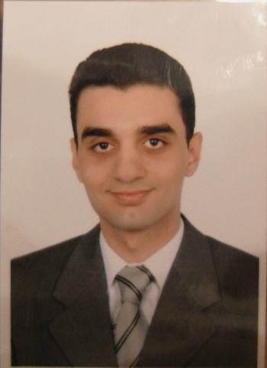
Hesham Elsayed Mohamed Ibrahim Aboloyoun
Assistant lecturer of Vascular Surgery,
Assiut University Hospital,
Assiut , Egypt
Personal data:
First name: Hesham
Middle name: Elsayed Mohamed
Last name: Aboloyoun
Tel: Home: +20882344490
Hospital:+20882413779
Mobile: +20121657612
E-mail: h_aboloyoun@yahoo.com
Date of birth: 1 May 1981.
Place of birth: United States of America (PA-Philadelphia)
Marital status: Single.
Nationality: Egyptian.
Address: Egypt, Assiut, 150 Nile st.
Correspondence: Egypt, Assiut, Assiut University Hospital, Department of Vascular Surgery.
Languages: Arabic and English
Current position:
Assistant lecturer of vascular surgery (since July 2009 till now ).
Positions held:
- House officer in Assiut university hospital (1 Mar 2005 to 28 Feb 2006)
- Resident in Department of Vascular surgery (Mar 2006 to July 2009)
Qualifications:
- High school diploma Dar Heraa School 1998
- MB.BCh: Faculty of Medicine, Assiut University 2004 (Excellent with honor degree).[1]
- M.Sc. In General surgery: Assiut University Hospital. [2]
Professional licensure: Egyptian Ministry of Health full registration no:172683
Clinical Experience:[3]
- Diabetic foot:
Care of diabetic foot,
Minor debridements
Toes amputations
Transmetatarsal amputation
Syme’s amputation
Below and Above knee amputation.
Disarticulation of hip joint.
Below and Above elbow amputation.
- Venous diseases:
Diagnosis and management of venous insufficiency
Diagnosis and management of DVT
Diagnosis and management of venous ulcers
Stripping of great saphenous vein
Foam therapy for varicose veins
Assistant in Valvuloplasty operations.
- Chronic ischemia:
Diagnosis and treatment of chronic ischemia
Fem-fem bypass
Fem-distal bypass
Fem-fem bypass
Axillo femoral bypass
Assistant in ilio femoral bypass
Assistant in profundoplasty
- Acute ischemia:
Femoral , popliteal and Brachial Embolectomy
Intra-arterial thrombolysis
- Dialysis access:
Radiocephalic AVF
Brachiocephalic AVF
Transposition of Basilic vein AVF
ePTFE graft fistula of upper and lower limbs
- Endovascular intervention:
Dilatation and stenting of SFA
Assistant in tibial vessels dilatation
Assistant in iliac artery dilatation and stenting
- Aortic surgery
Assistant in exclusion of AAA
Assistant in Aorto-bifemoral bypass
- Trauma:
Repair of peripheral arterial injuries including Femoral, Popliteal, Brachial, Axillary vessels
Assistant in carotid artery repair
Assistant in IVC repair
- Carotid surgery:
Assistant in carotid endartrectomy.
- Others:
Lumbar sympathectomy
Assistant in trans thoracic sympathectomy
Assistant in cervical rib resection.
Teaching activities:
- Supervising House Officers since March 2006
- Senior Resident supervisor since March 2008
- Undergraduate teaching of the final year medical students since March 2009
Graduate courses, postgraduate trainings and conferences attended:
- 1998-2004: Graduate studies, Faculty of medicine, Assiut University
- 2005-2006: House officer, Assiut University Hospital.
- 2006-2009: Resident in Vascular Surgery Department.
- 2005-2010: Attended the annual conference of Assiut faculty of medicine.
- 2009: six months training in General Surgery Department
References and confirmation:
[1] Assiut University was inaugurated in 1957 to encourage research, education and community services in Upper Egypt. It is located in Assiut City which is 375 Km south of Cairo, the capital,. The University comprises sixteen faculties and two higher institutions. PO Code N; 71515, Egypt. http://www.aun.edu.eg
[2] Assiut University Hospital is one of the largest University Hospitals in Egypt. It is the core referral center for the whole Upper Egypt that serves about 20 million people. http://www.aun.edu.eg/fac_med/medicin/hospital2.htm
[3] Professor Dr. Hassan Bakr Al-Badawy; Professor and founder of the Department of
Vascular Surgery in Assiut University Hospital.

